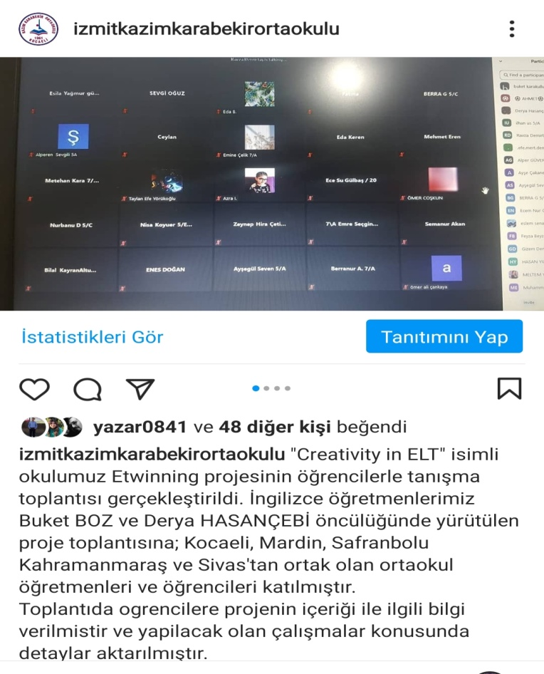
''CREATVITY IN ELT'' E TWİNNİNG PROJEMİZ

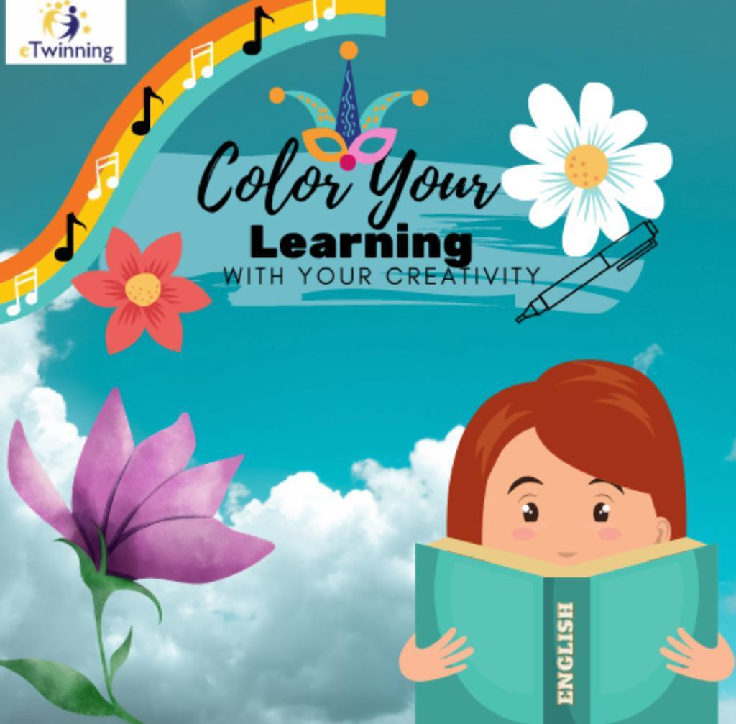

ANKET SONUCU BELİRLENEN LOGOMUZ

